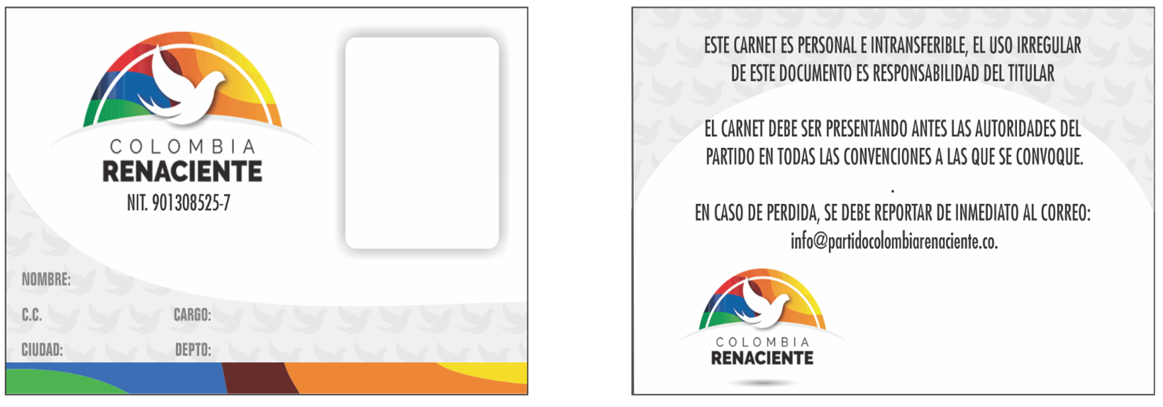

**MILITANTE**

**HENRY MANUEL MELENDEZ SILGADO**

**92448775**

**SINCELEJO**

**SUCRE**

*70924487751*